Health path
Lukas has a dream to be strong and healthy. You can help him to make his dream come true.
Goal of the game:
Your goal is to accomplish Lukas dream by reaching the end of the health path.
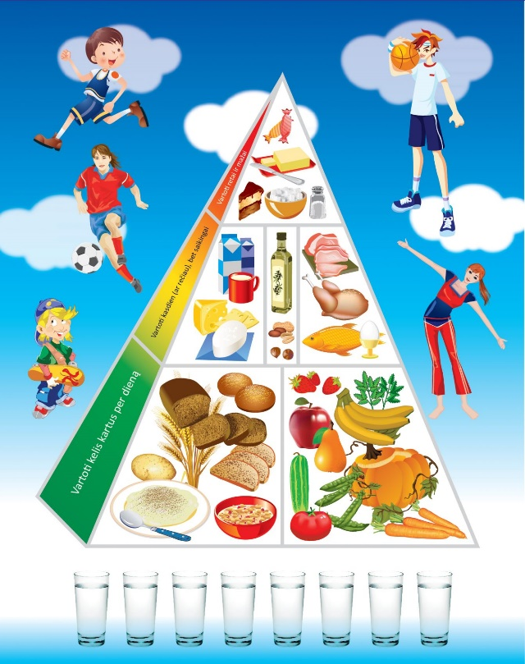
How to play:
1) Each players has a game figure to travel through the game board. Everyone puts their figures of the game on the field number 0.
2) The oldest player starts the game and goes clockwise.
3) As their first turn every single player rolls the dice to move forward.
4) On their second turn players look at the color of the field that they are standing on and do further steps.
5) There are five different types of fields. According to the type of the field on which the player stands, the game goes this way on:
Grey – alcohol drinks – roll the dice twice and go backwards as many fields as you got by rolling the dice. (2)
Red – junk food - roll the dice one time and go backwards as many fields as you got by rolling the dice. (17)
Yellow – middle section – do nothing, just skip the turn. When your second turn comes you have to roll the dice and go forward as many fields as you got, so you would move to another field.(15)
Green – healthy food - roll the dice one time and go forward as many fields as you got by rolling the dice. (31)
Blue – water - roll the dice two times in a row and go forward as many fields as you got by rolling the dice. (1)
Be careful and do not get lost!
The end of the game
The game ends when all the players get to the end of the health path. The winner of the game is the one that finished the path first!

*Extra steps. Whoever is the first one to find and show the gap, where four fields are missing, gets the chance to roll the dice two extra times, whenever they want.

